**Machine Learning – Lecture Notes – Part III**

**Week 8**

**Unsupervised Learning**

**Introduction**

* In a supervised learning problem, we are given a set of labels and we must fit a hypothesis to it.
* In an unsupervised learning problem, our training data has no labels. We simply ask unsupervised learning algorithms to find some structure in the data for us.
* We can use a clustering algorithm to find clusters in data as follows.

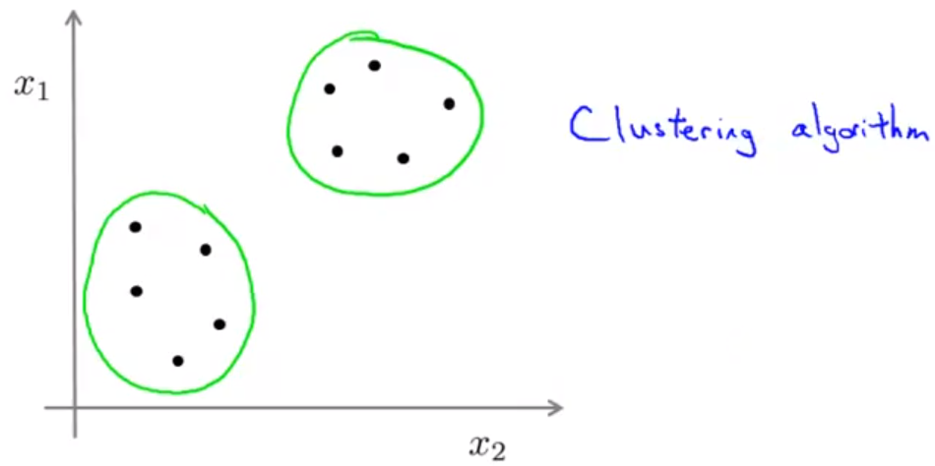

* Some applications of clustering include market segmentation, social network analysis, organizing computing clusters, astronomical data analysis, etc.

**K–Means Algorithm**

* Given an unlabelled data set, we first create **cluster centroids** randomly in the data set, where is the number of clusters we want to group the data into. Then, there are 2 main steps in the algorithm.

1. First, we colour each of the data points based on which of the centroids it’s closest to.
2. Then, we move each of the centroids to the average of its coloured data points and we repeat the process.

* We iterate through these steps until the cluster centroids are at the centroids of their clusters.

K–Means Formalized

* Input
  + (number of clusters)
  + Training set , and we say (drop the convention)
* Randomly initialize cluster centroids .
* Repeat {
  + for
    - index (from 1 to ) of cluster centroid closest to using .
  + for to
    - average (mean) of points assigned to cluster
  + }
* If a certain cluster has no points closer to it, then you can either (a) eliminate that cluster so there are clusters or (b) reinitialize that cluster centroid at a new location.

K–Means for Non–Separated Clusters

* Even when it looks like there are no clusters in the data, we can make clusters out of it.
* For example, given people’s heights and weights, we can segment the market for T-shirts into 3 different classes of data – small, medium and large, and design T-shirts based on those market segmentations.

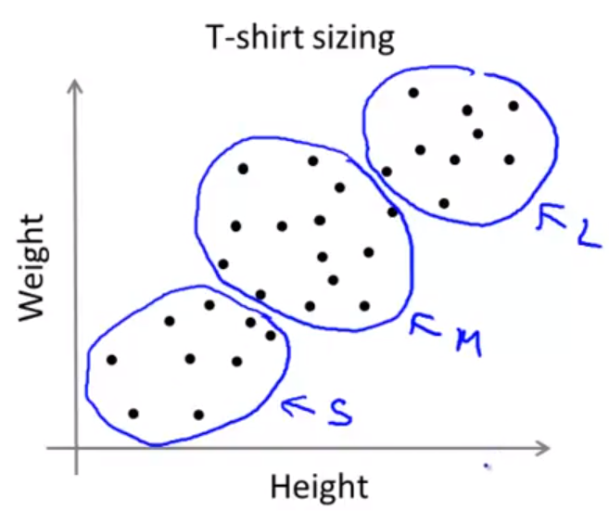

**Optimization Objective**

K-Means Optimization Objective

* Notation:
  + index of cluster () to which example is currently assigned
  + cluster centroid , where
  + cluster centroid of cluster to which example has been assigned
* Optimization objective:
* The K-means algorithm first minimizes with respect to and then with respect to .

**Random Initialization**

* Should have .
* Randomly pick training examples , where is the random training example.
* Set for these examples.

Local Optima

* However, it is very possible that K-means gets stuck at a bad local optima that prevents it from reaching the global optimum.

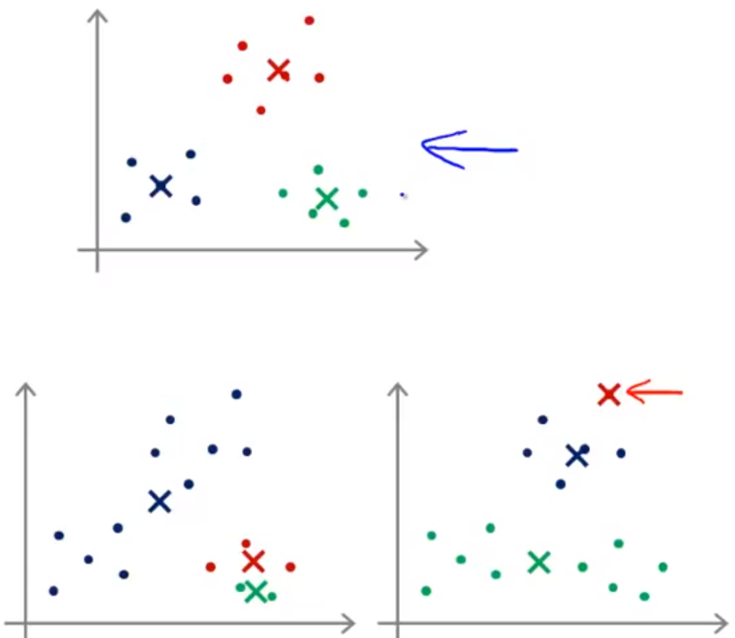

* To prevent this issue or get higher chances of remedying it, we can run random initialization many times and compare the cost function at each iteration and keep the best one.
* for to {
  + randomly initialize K-means
  + run K-means and get
  + compute cost function
  + compare to the previous cost function and keep the parameters that yield lowest cost
  + }

**Choosing the Number of Clusters**

Elbow Method

* We run the K-means algorithm with varying number of clusters and plot the minimum cost .
* Ideally, there is an “elbow” at which point, from the left, the cost function is decreasing rapidly, and from the right the cost function is decreasing slowly.

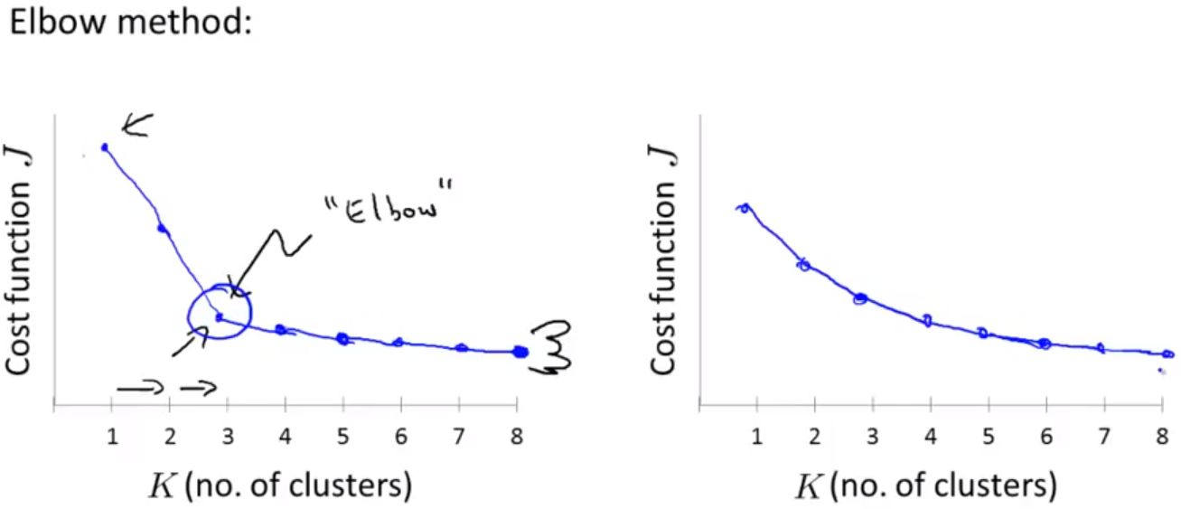

* However, we often end up with a curve on the right, where the elbow of the curve is ambiguous.

Choosing the Value of K

* We can train a current dataset based on how many clusters we will look for eventually. For example, in the market segmentation for T-shirts, we group the heights and weights of individuals into 3 categories to make a S, M, and L size for people.
* If I want more categories, namely XS, S, M, L, XL, then I pick .

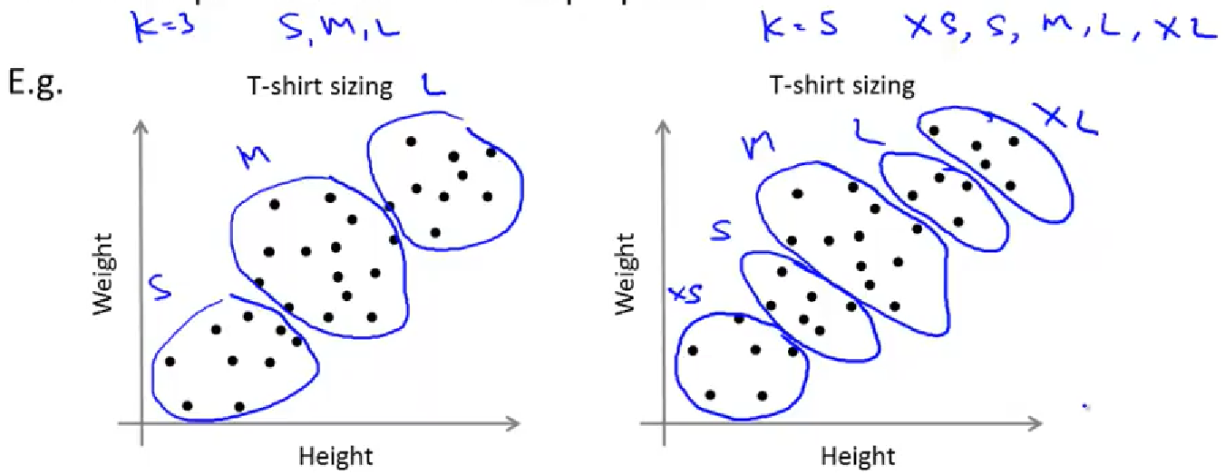

**Motivation I: Data Compression**

Dimensionality Reduction

* Reducing data from a higher dimension to a lower dimension (e.g. 2D 🡪 1D).
* If most data points sit on a straight line, then we can approximate both features by just using the *x-*value of the data points.

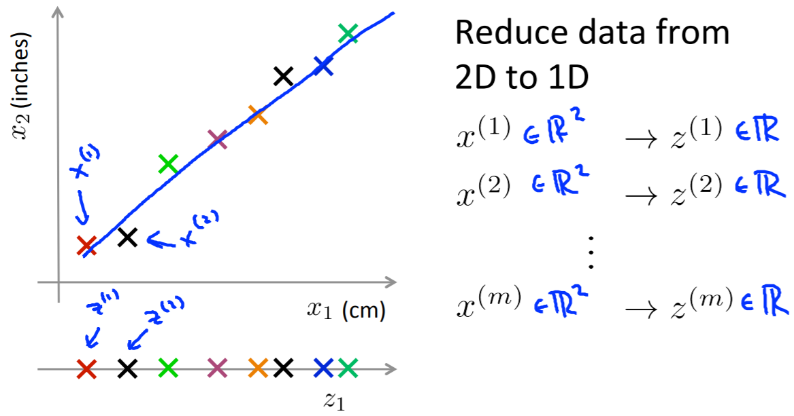

* Similarly, we can map 3D 🡪 2D if all/most of the data points lie on a single plane. We can make two axes to represent the distance along each of the axes of the plane.

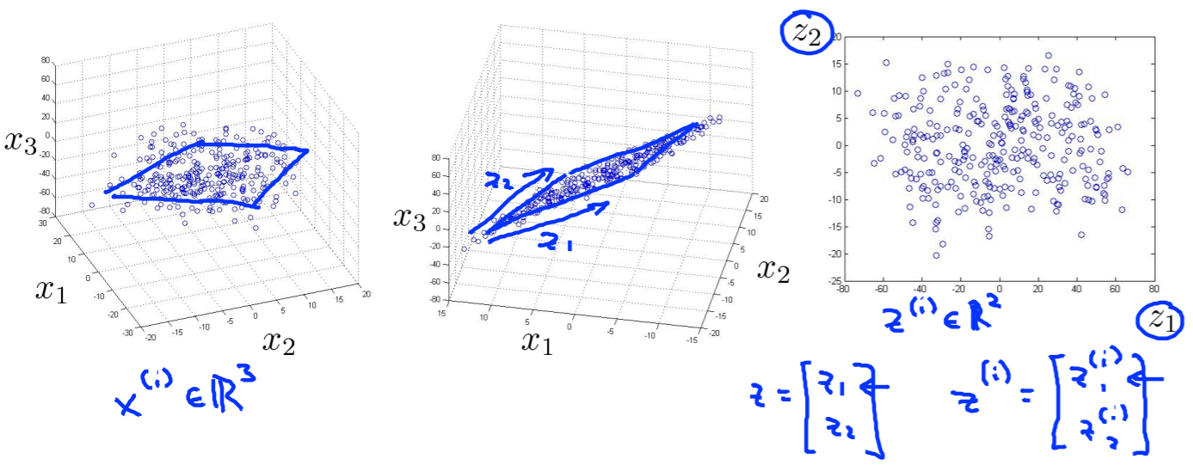

* Reducing the dimension data both saves storage space because less numbers are needed for the same data and makes learning algorithms more efficient since they require less computation.

Motivation II: Data Visualization

* When given data of high dimensions, such as 50-dimensional data, it is hard to visualize it.
* Using dimensionality reduction will help group certain features together to get lower dimensional data (i.e. 2D or 3D data) that can be plotted. This gives a better understanding of the data.
* For example, given many statistics about different countries like GDP, GDP per capita, HDI, life expectancy, Gini coefficient, mean household income, etc., we can reduce these figures into 2 categories: country size & per-person GDP (economic activity), yielding a graph like below.

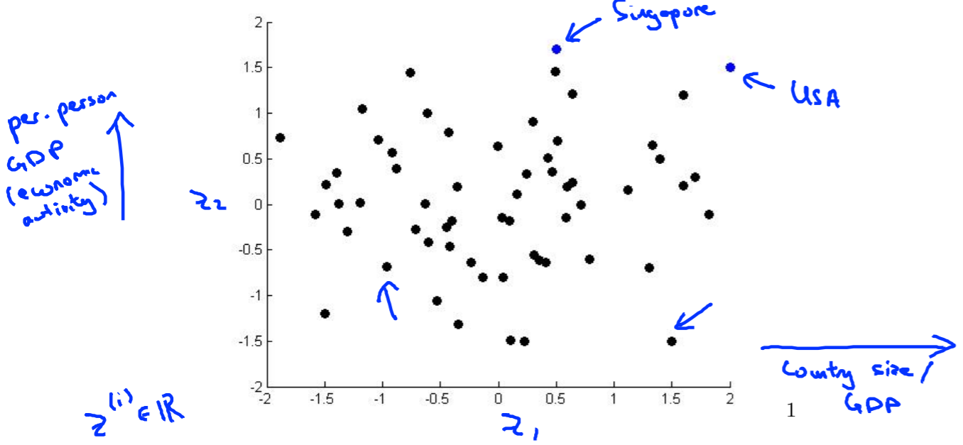

**Principal Component Analysis (PCA) Problem Formulation**